**ECE-3502 IoT Domain Analyst LAB(L9+L10)**

**Name: Alpanshu Kataria**

**Reg. No.: 18BCE1267**

**Faculty: Dr. Maheshwari R**

Lab 11

**Task:**

Machine Learning (Unsupervised Learning) in Knime analytics platform for applying clustering on corona virus related dataset

**Dataset:**

https://www.kaggle.com/sudalairajkumar/covid19-in-india?select=covid_19_india.csv

**Workspace:**

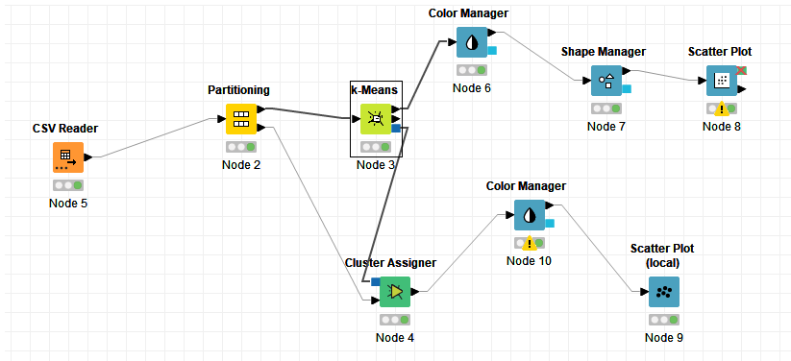

**All nodes and their configuration:**

**CSV reader**

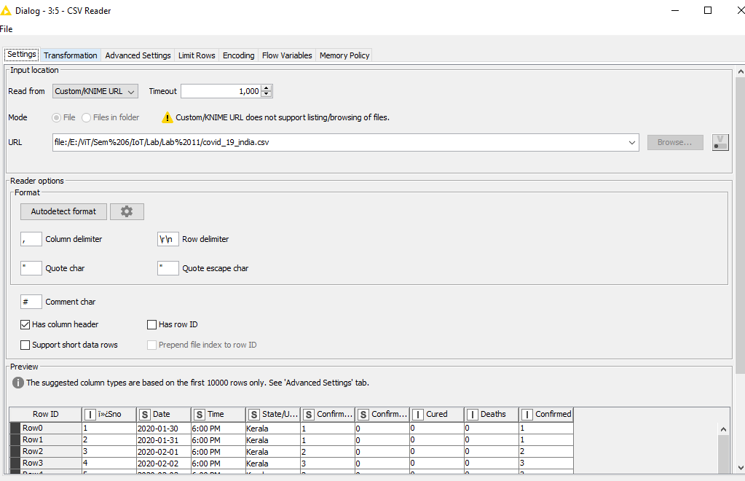

**Partitioning Node:**

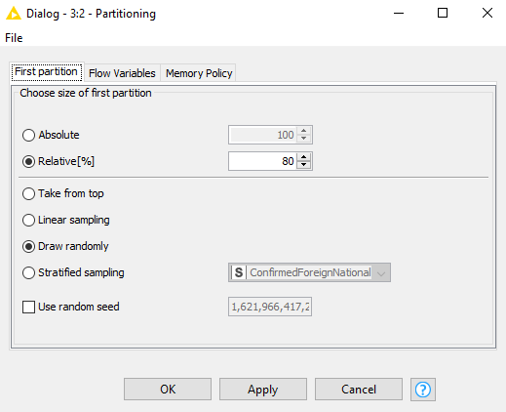

**K-means Node:**

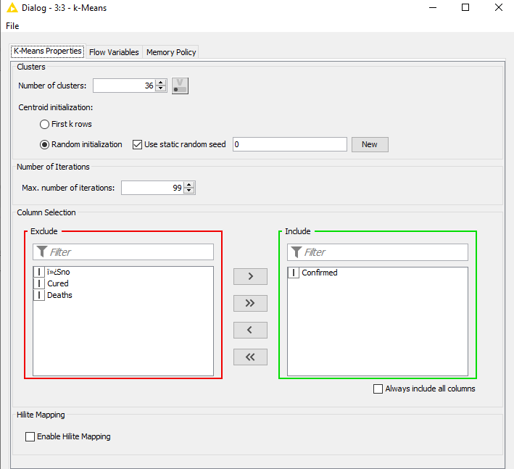

**Color Manager Node:**

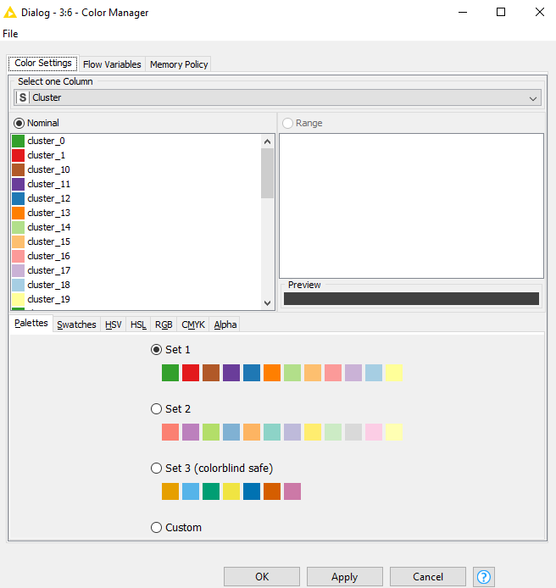

**Shape Manager Node:**

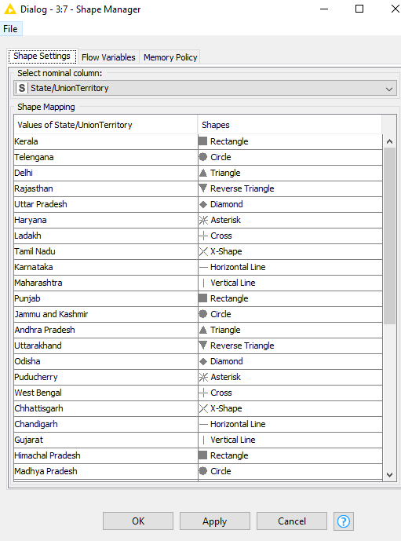

**Scatter Plot Node:**

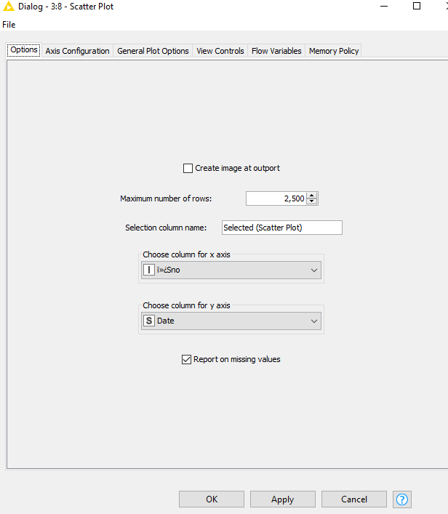

**Cluster Assigner Node:**

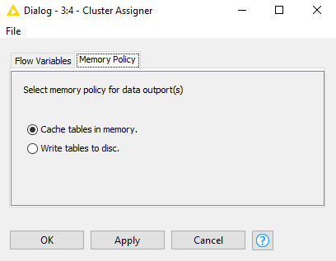

**Scatter Plot Output:**

